**“Training handout”, November 2024**

**SpeedSwivel FDC Adapter:**

The use and care of a SpeedSwivel. For classroom or sales introductions.

**SUBJECT: The SpeedSwivel FDC adapter**

A SpeedSwivel provides firefighters with a tool and a solution for connecting fire hose to a fire department connection (FDC) when the brass swivels are missing or have been stolen.

1. **SPEEDSWIVEL TRAINING HANDOUT**

A. Defines the Speed Swivel.

1. Establishes the issuance of the SpeedSwivel.

1. Establishes guidelines for appropriate use, care, and storage of SpeedSwivel.

**11. POLICY**

It is the policy of the ________ Fire Department to provide the necessary tools to assist when operating safely at the scene of an incident. The SpeedSwivel provides firefighters with a solution for connecting fire hose to a fire department connection (FDC) when the brass swivels are missing or stolen. Fire fighters shall be responsible for the proper care and use of this hose adapter.

**111. DEFINITIONS**

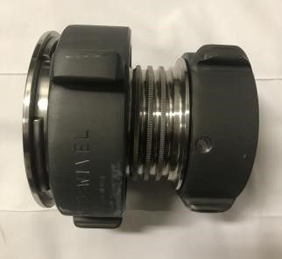

**SpeedSwivel:** A fitting that replaces a missing **FDC** female swivel by fitting over and tightening onto the ball bearing raceway.

Locking Collar

2 ½” female swivel connection

**Page 1 of 4**

**IV.** **OPERATIONAL USE OF THE SPEED SWIVEL**

The SpeedSwivel shall be used when the 2 ½” female swivel of an FDC has been stolen or is missing. When connecting to a vandalized FDC the member shall:

* + - 1. Ensure the barrel of the FDC is clear of debris and that there is no damage to the ball bearing raceway of the missing swivel.

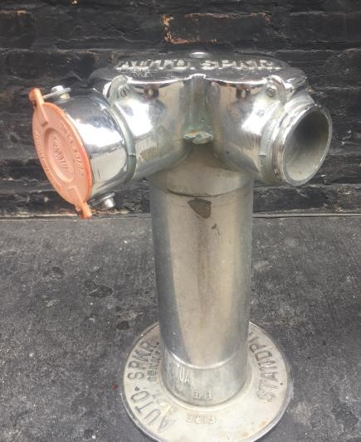

Female Swivel Bearing Raceway

* + - 1. Confirm the SpeedSwivel is in the open position by turning the Locking Collar counterclockwise until the four locking mechanisms have retracted back into the housing.

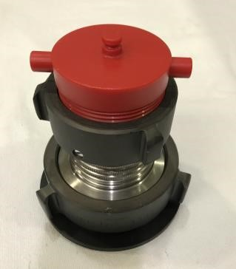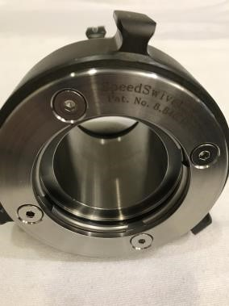

Locking

Collar

Locking

mechanisms

**Page 2 of 4**

* + - 1. Place the SpeedSwivel onto the intake port of the FDC with the 2 ½” female swivel connection of the Speed Swivel facing out.

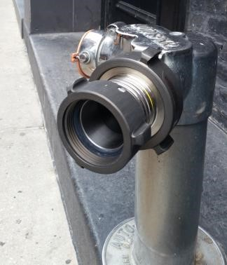

2

½” female swivel

connection

* + - 1. Turn the Locking Collar clockwise (or to the right) until it is hand tight.

Locking Collar

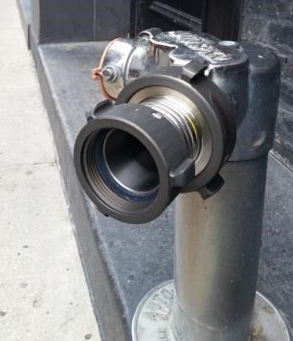

* + - 1. Attach the 2 ½” fire hose to the 2 ½” female coupling provided on the SpeedSwivel.

**NOTE:** Depending on the age and condition of the existing FDC, some leaking around the fitting is always possible. Check gaskets as needed.

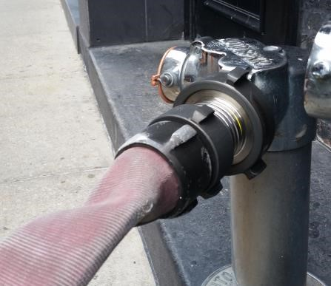

2

½” hose

2

½” female swivel

connection

**Page 3 of 4**

**Protective Cover**:

One side of the “Protective Cover” has a **ball-race** that duplicates the size and shape of the ball-race found on a vandalized FDC. When the SpeedSwivel and the protective cover are attached to each other, **s**pinning and pulling aggressively at the protective cover **will not** allow its removal!

To remove the protective cover simply grip the SpeedSwivel by the barrel section with the largest coupling facing up & smallest coupling facing down.

Spin the largest rocker lug Coupling only 3 to 5 spins. Only enough spins to remove cover.

The knowledge needed by a firefighter to remove & attach this dust cover will reinforce the knowledge needed to attach the SpeedSwivel to a “Vandalized FDC” in an emergency. This “Protective cover” is also a useful training prop

Dropping the coupling completely off the main body is only for cleaning.

The protective dust cover is recommended with every SpeedSwivel. The protective cover should **remain attached** when a device is stored in a truck compartment and not in use.

Other considerations may include:

1. Fire fighters shall be responsible for the proper care and use of this hose adapter.
2. Refer to NFPA 1962 for care and maintenance of fire hose, nozzles, and adapters.
3. Upon receipt, the Speed Swivel shall be added to all appropriate truck inventories.
4. Any damage and/or signs of wear to the Speed Swivel shall be reported.
5. Check female threads for compatibility with your departments 2-1/2-inch male hose.
6. USA made, meets all NFPA requirements.
7. Exclusively manufactured by Red Head Brass

**Red Head distributors or Fire instructors may print contact name here.**

**Details on the SpeedSwivel 2024 version & more can be found at:** [**www.Redheadbrass.com**](http://www.Redheadbrass.com)

**It’s Risky to be Without a SpeedSwivel FDC Adapter on Apparatus Inventory**

**Handout intended to facilitate the introduction of SpeedSwivel Adapters.**

**(**SpeedSwivel FDC Adapters: U.S. Patent No. 8,840,149)

**Page 4 of 4**